Please feel free to use this to help you 1) set your PICO question and 2) search in future.
Basic clinical question/ idea: ________________________________________________________
________________________________________________________________________________________________________________________________________________________________________
PICO framework and search terms:
 | Keyword |  | Synonym
P |  | OR
AND
I |  | OR
AND
C |  | OR
AND
O |  | OR

Search list to combine for first advanced search: ________________________________________________________
________________________________________________________
Refinements: ________________________________________________________________________________________________________________________________________________________________________
Worked example

Basic clinical question/ idea: A 12 year old female is having trouble reading at school and has been referred for assessment and management. She has attended your clinic to see whether colour lenses could be beneficial for her learning.

PICO framework and search terms:
- The parts of a PICO question are developed first and written down the first row. Within each section of the PICO question, use the Boolean term AND in your searches so you find articles with all these aspects. Likewise if you have multiple aspects within the one section (e.g. P) you can use AND to find articles that include both.]If you do, the articles will be more relevant.
- Each part of the PICO question may have more than one term to explain that term. Given that databases can differ as to the search entries stored and researchers may use different terms (e.g., in different places), it is a good idea to determine synonyms of these terms. Synonyms within each level are separated by OR to show you will accept either term.
- Finally use an asterix (*) as a truncation term. For example if you write len* this covers lens, lenses and other word endings so you don’t have to write all the forms yourself.

 | Keyword |  | Synonym
P | Child*AND  Reading difficulties | OR | Dyslexia
AND
I | Colour*  Len* | OR | Color*  Irlen  overlay
AND
C | none | OR
AND
O | Improved vision | OR

Search list to combine for first advanced search:
(Child*) AND (reading OR learning) AND (colour* or color* or Irlen) AND (len* or overlay) AND (vision)
Please note: Many databases offer a builder search to walk you through building a search up using AND, OR and NOT as needed. If you work on your PICO using the table, instead of filling in individual search boxes, you can just add your text into the search box and go.
For example, here is how it worked in PubMED. 5/6 relevant articles were found. 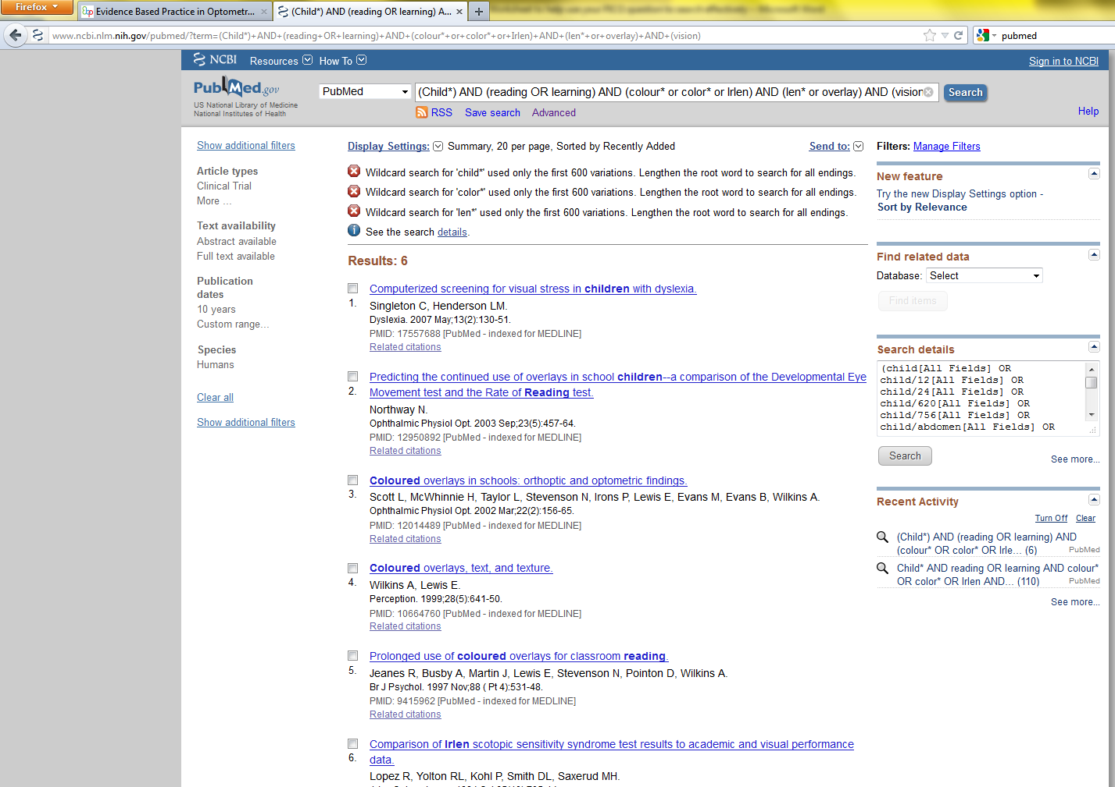
Refinements - tips:
- How can I further refine the search?
  - Click on search details or similar to see what the computer searched for. You may find an error or something you want to omit. To do that, go back up to your search text and add NOT then the keywords you want to avoid.
  - Start with secondary resources (summaries and syntheses of papers) to see what has already been compiled and potentially appraised on the topic. For more information see: http://www.eboptometry.com/content/optometry/ebp-resource-step-2-acquire/optometrists-students-teachers/syntheses-and-summaries-links-eye-health-professionals
- I didn’t find anything? What should I do now?
  - Sometimes specific searches do not provide any hits – because there is nothing covering all those terms. Here are some logical next steps:
    - Broaden your search by omitting less important details or changing some ANDs to ORs.
    - Check you have enough synonyms. Disorder names and sometimes even intervention names can differ across countries. Do a quick basic search of an internet search engine (e.g., Google, Yahoo etc) to see if there are other terms you may have missed the first time.
    - The other thing to keep in mind is where did you search?
      - Was it the right database for the topic? For example, maybe PubMED, Medline or EMBASE is not the best choice for behavioural optometry. Something like TRIP (www.trip.org) searches multiple databases at once which might help you cover more ground.
      - Did you search for secondary resources but could not find any? In which case you now need to find individual studies (primary sources) to help answer your question.
- I have found so many references I’ll be here all day! What should I do?
  - Don’t stop there as it will become a time-consuming task! Be more specific with your terms to specify exactly what you want to find. You may start off with a broad question on a topic you know little about, but after seeing the result list and reading a couple of abstracts you may have a better idea of what you want, or what you don’t want.
For more details on asking clinical questions and searching, please go to www.eboptometry.com

